1. IP address：140.113.137.177

IP port：52954

1. IP address：128.119.245.12

IP port：80

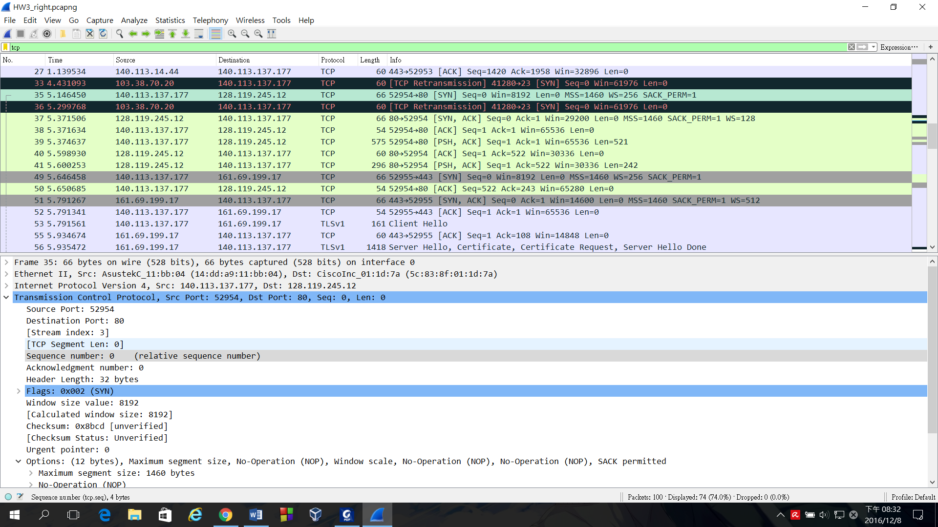

1. 0，the Syn flag is set to 1 and this identifies the segment as a Syn segment.

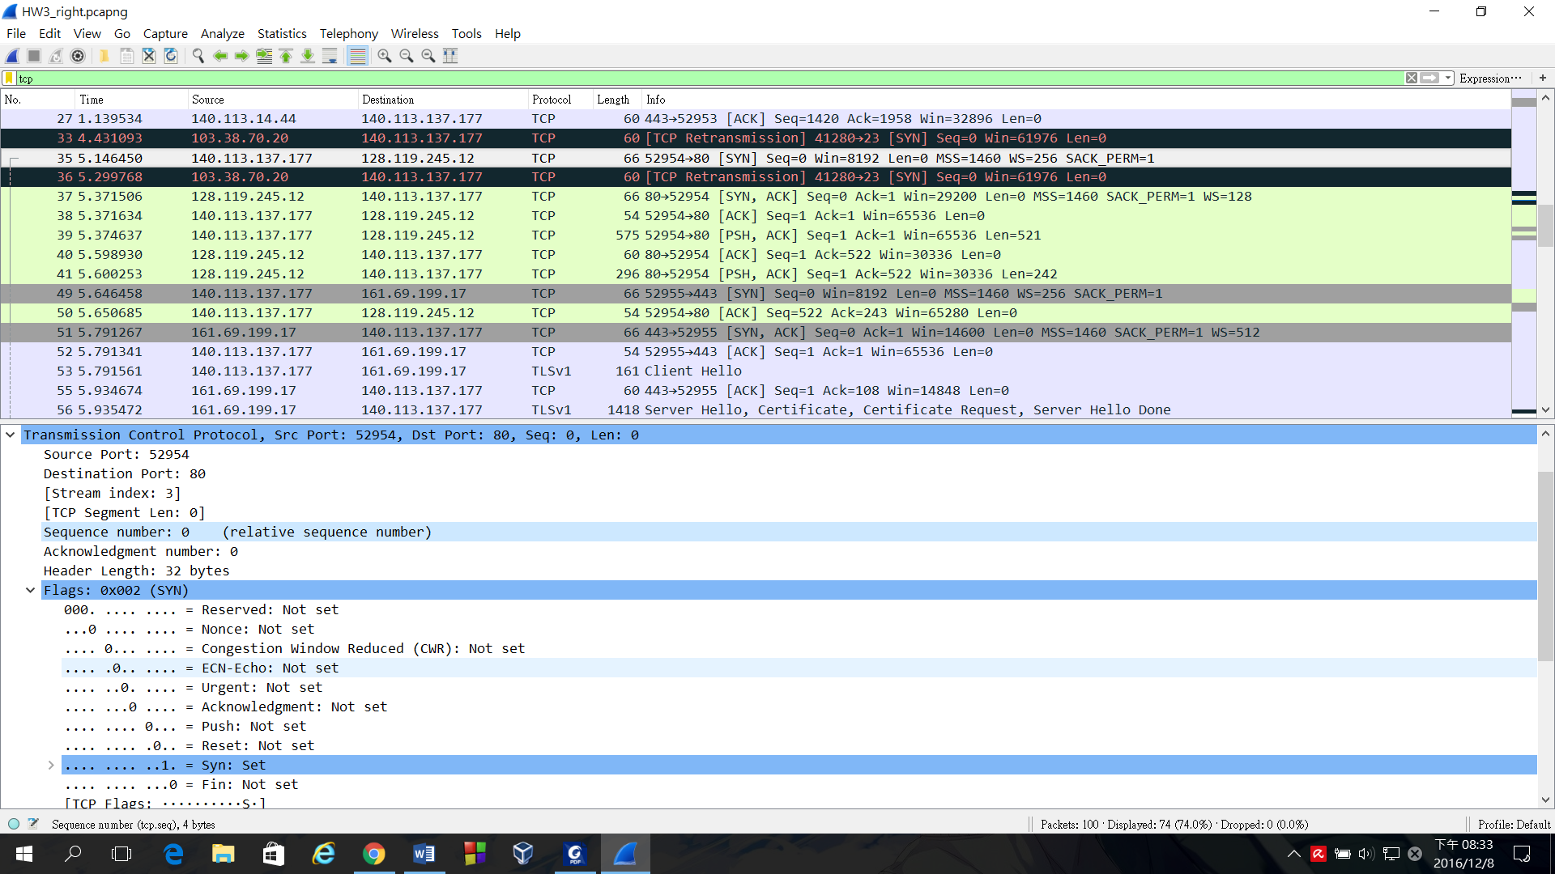

1. 1，the Syn flag and the Acknowledgment flag are both set to 1 and this identifies the segment as a Syn-Ack segment.

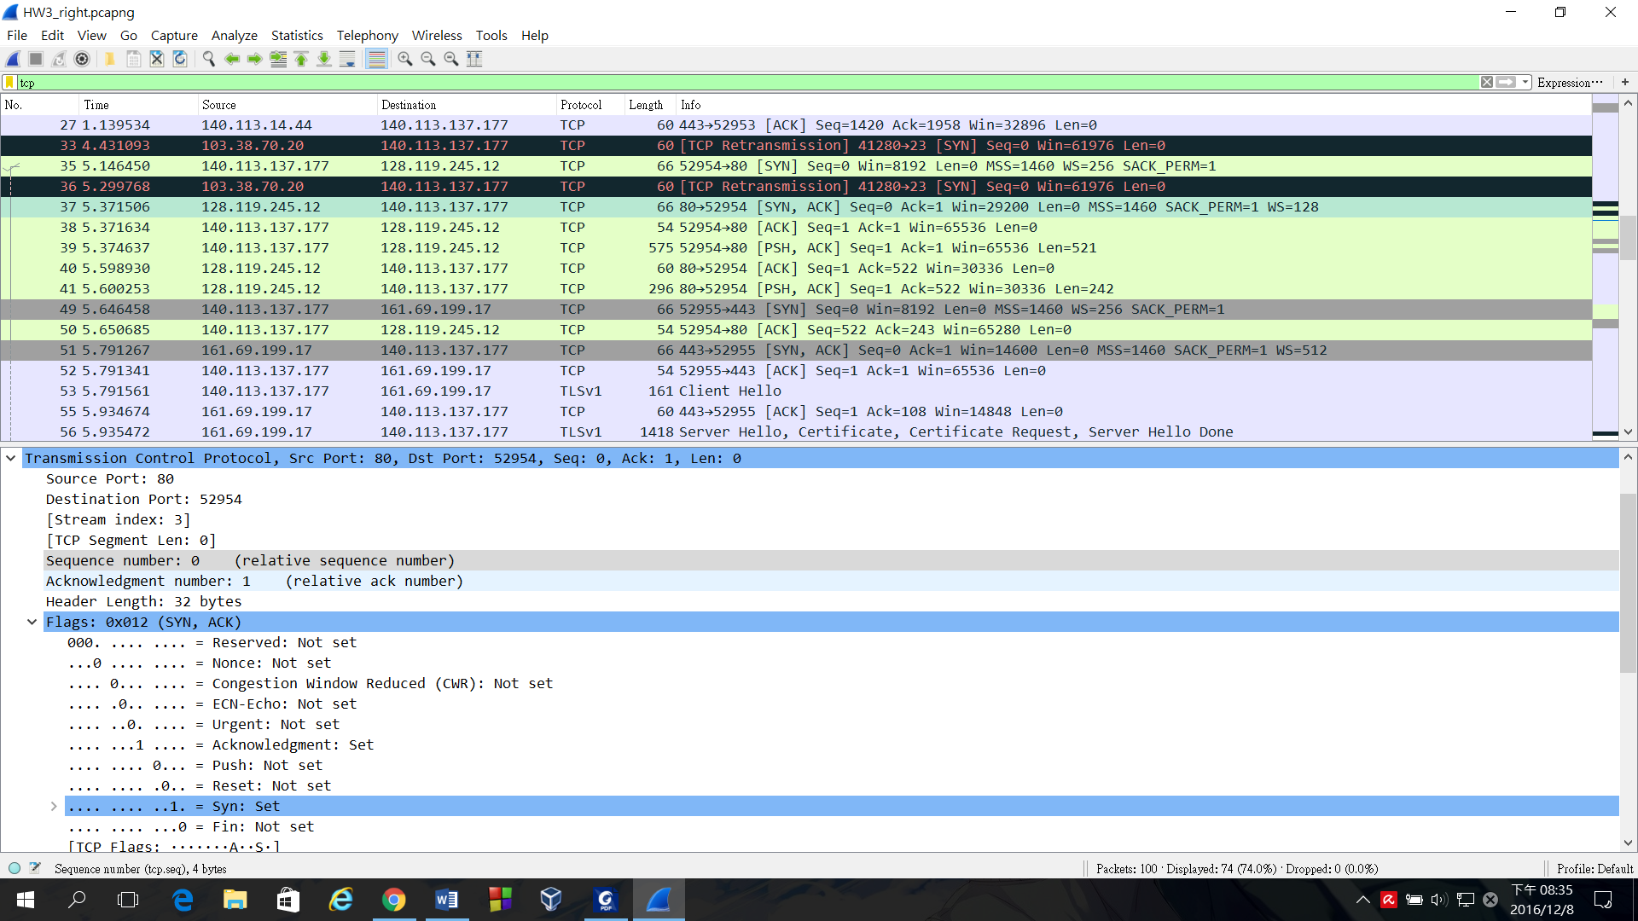

1. 522

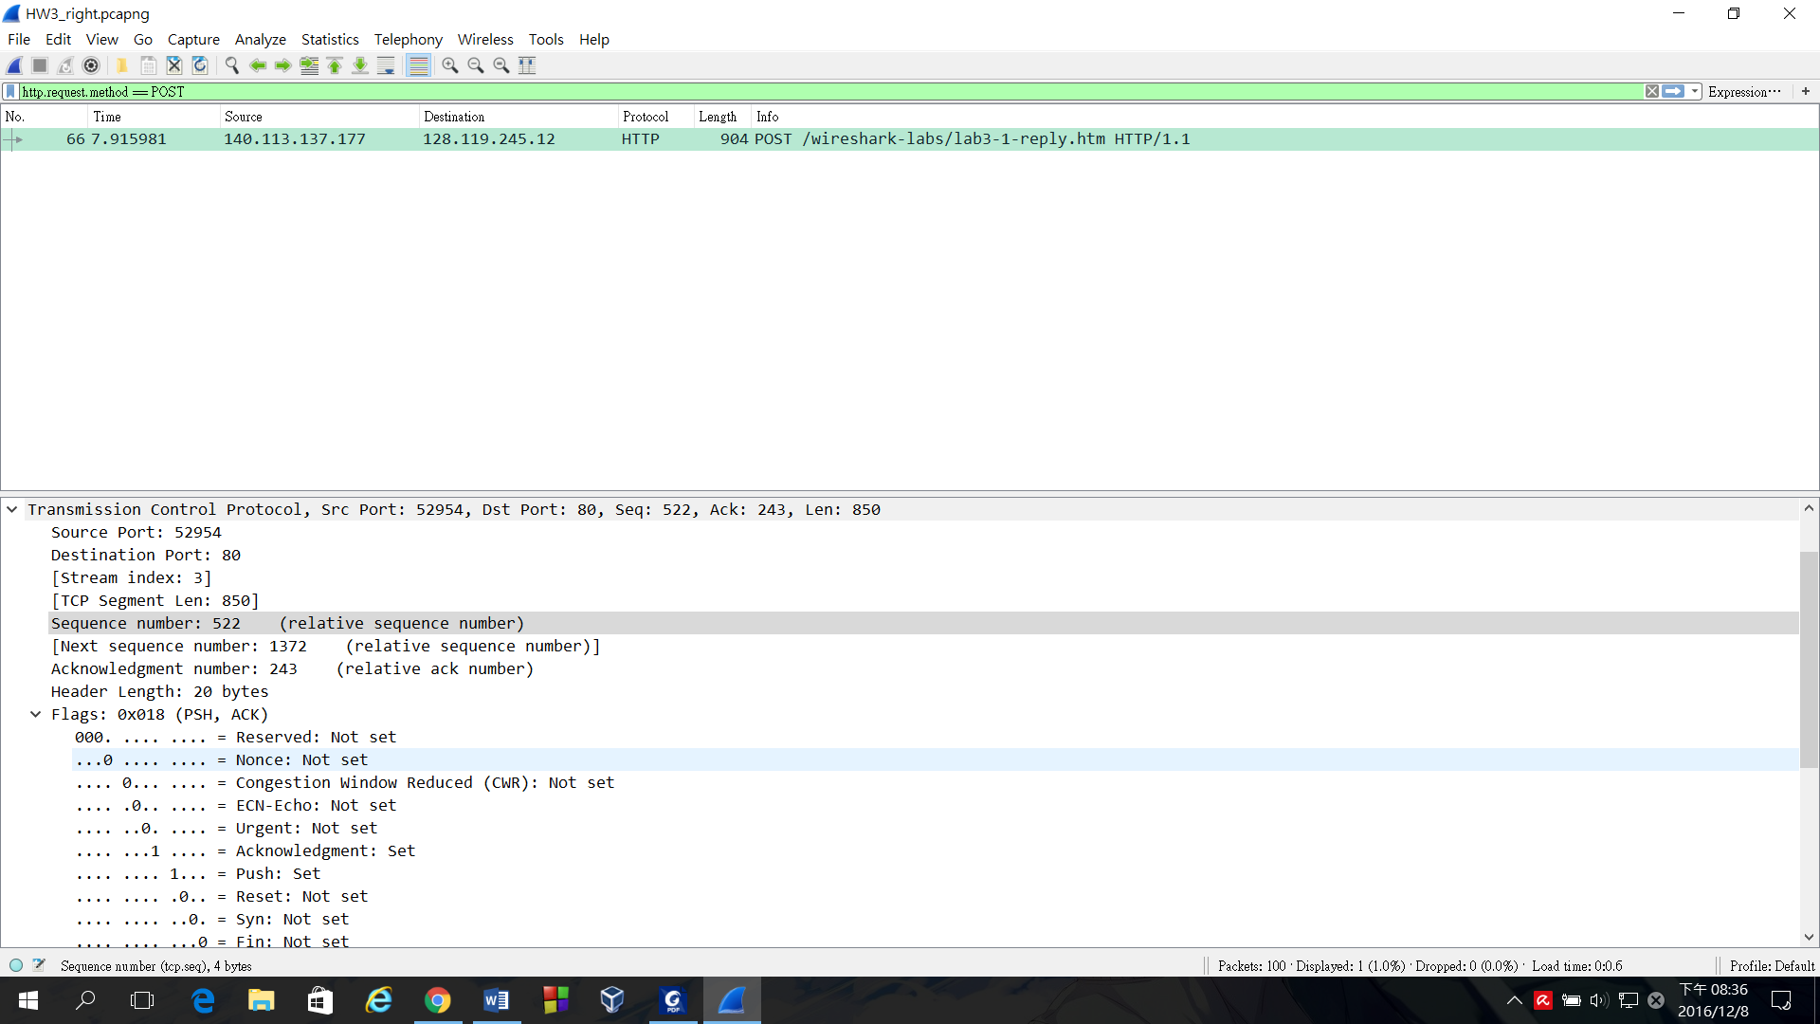

1. 1460 bytes

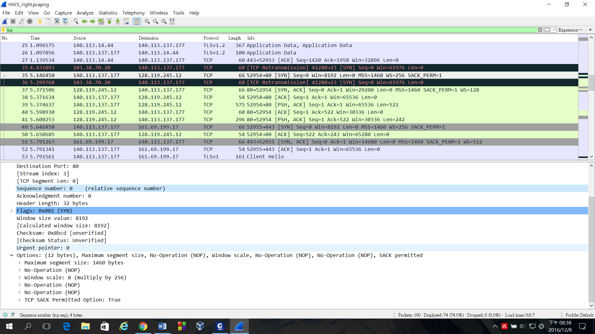

1. 29200 bytes

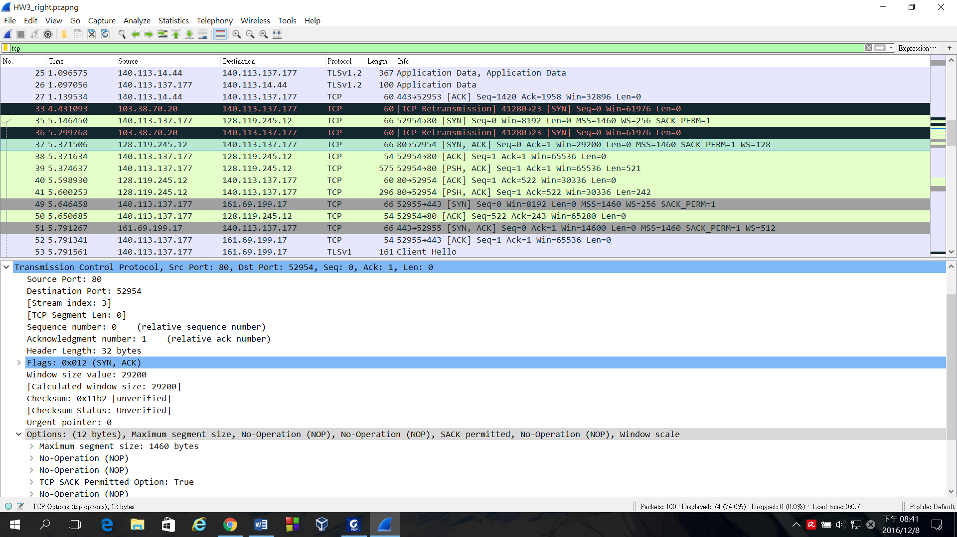

1. Total amount data transmitted：

the acknowledgment number of the last segment – the sequence number of the first segment = 1021 – 1 = 1020 bytes

Total transmission time：

8.191373 – 5.374637 = 2.816736

1020 / 2.816736 = 362.121264 bytes/sec

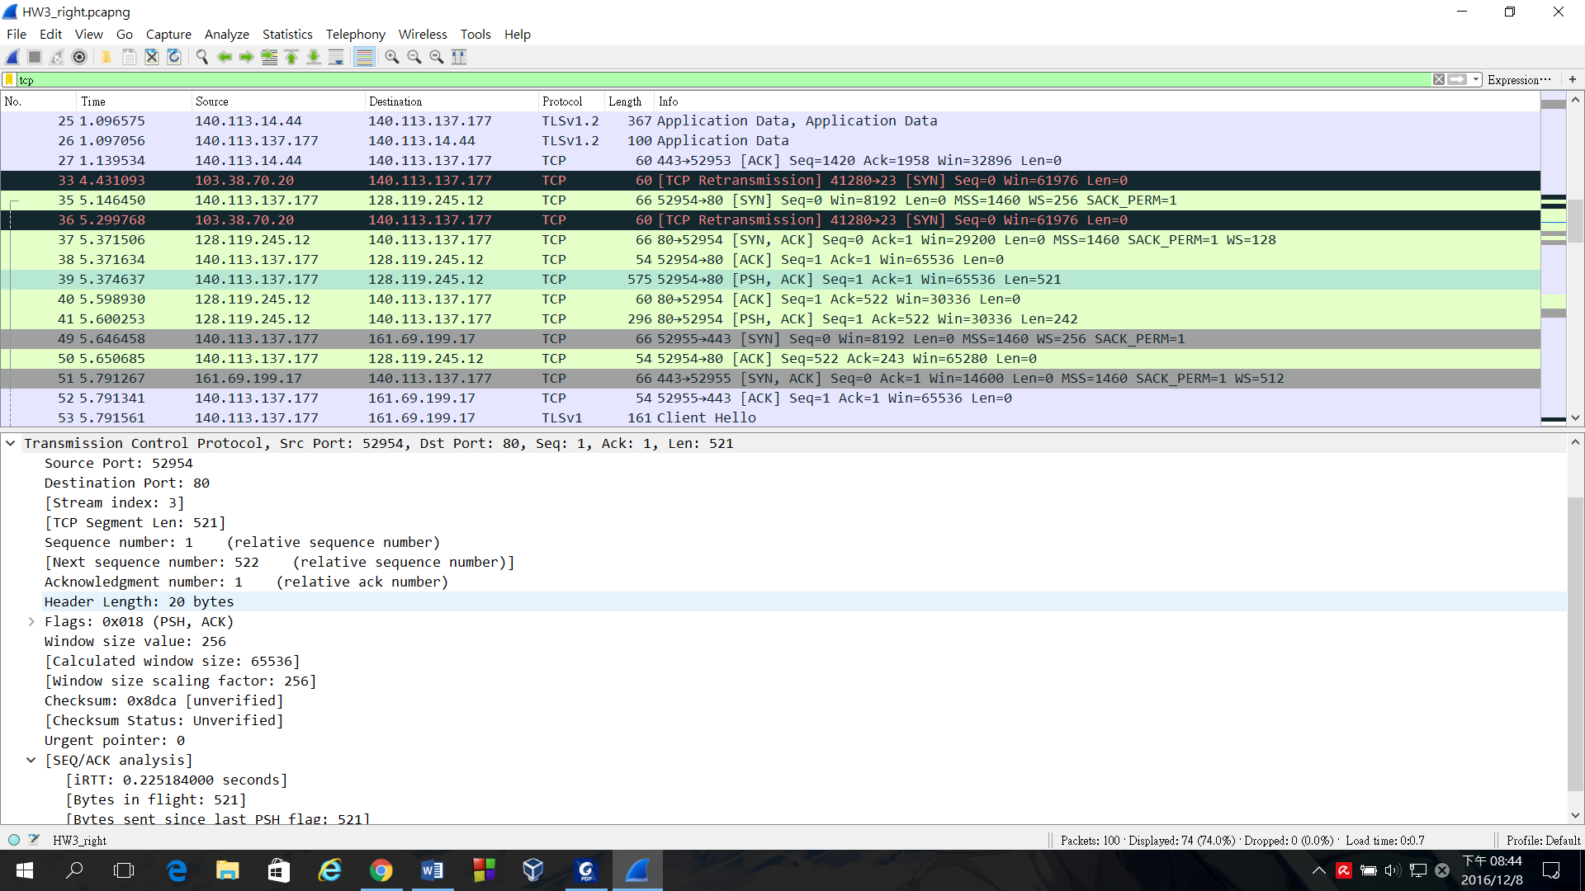 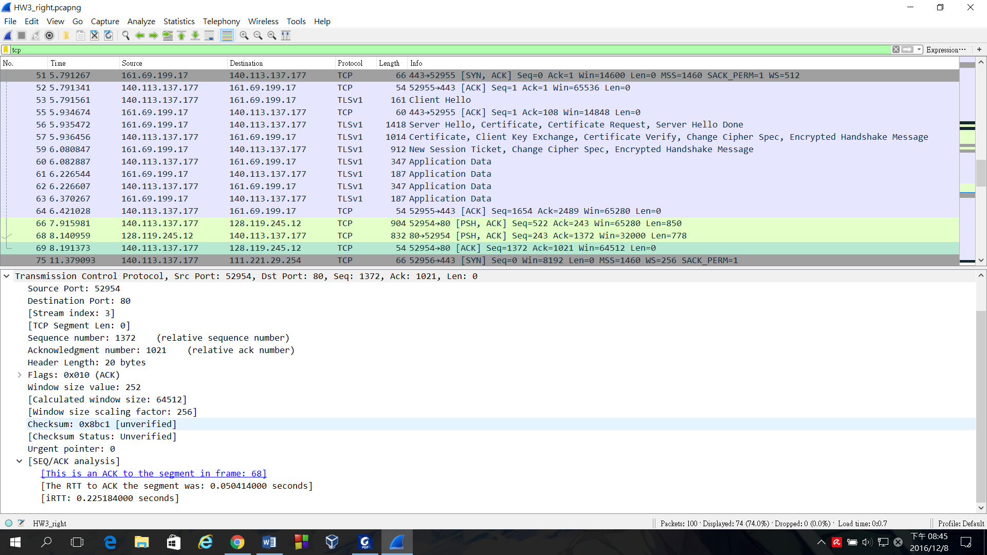

加分題：1.因為data大於MMS的大小，故TCP要分段送出去

2. the host uses two tuple ( destination id and destination port ) and sequence number to identify the TCP segments which belong to same application message.

心得：這次的實驗主要是在了解TCP的運作方式，透過這次的實驗我對上課所教的東西更有實感，不會只有抽象的觀念而已，有種我在運用上課所學的感覺。網路這種東西比想像中還要複雜，簡單的上傳資料就需要透過很多次的來回聯絡，之前可能只是覺得：喔這樣啊。 做完這次作業，對於這種東西的複雜度更加了解，也對於創立protocol的人更感佩服了。